PrepSTEP: Preparing to take the PSAT
- Go to the “Library Media Services” tab on the RPHS homepage.
To get there: fortbendisd.com /Schools / Ridge Point High School



- Under “Most Popular RPHS Links”, click the PrepSTEP link:
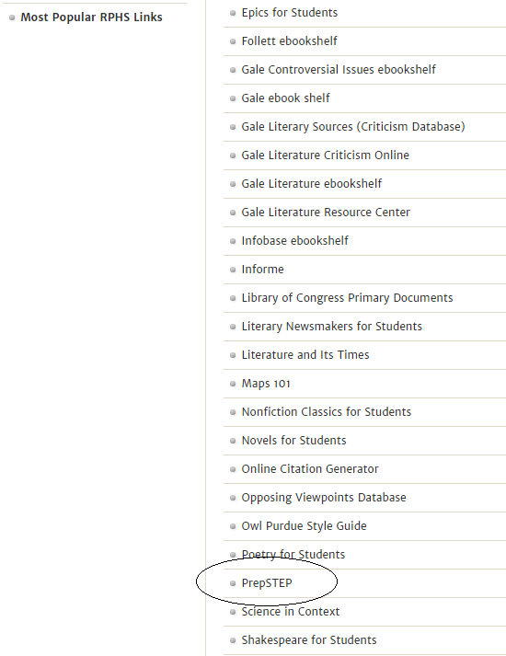

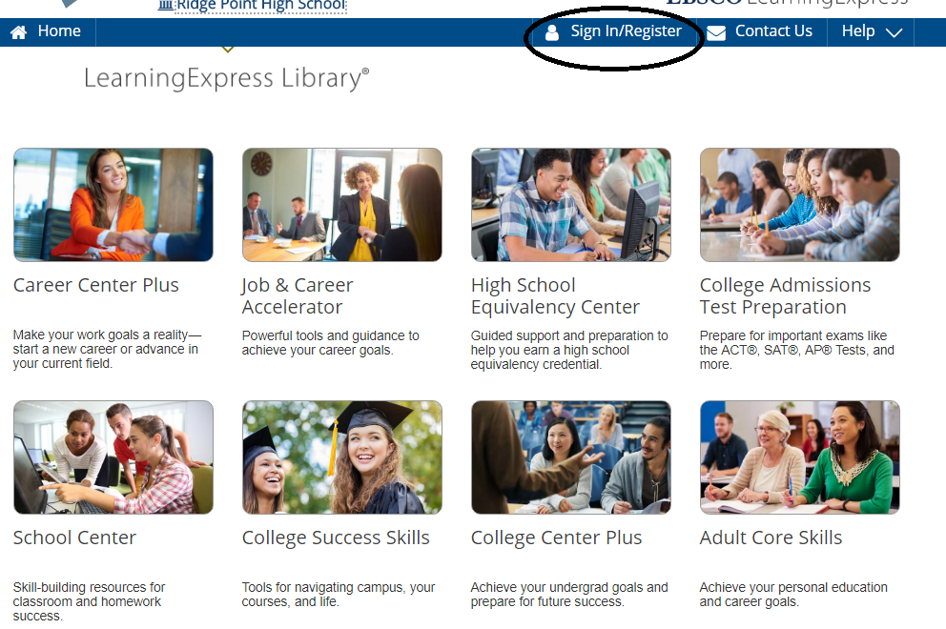
First time users: REGISTER using your school email and set your password.
Returning Users: This will be the Login each time you access PrepSTEP.
- To practice for PSAT, select College Admissions Test Preparation.


4. Select Prepare for your PSAT Test
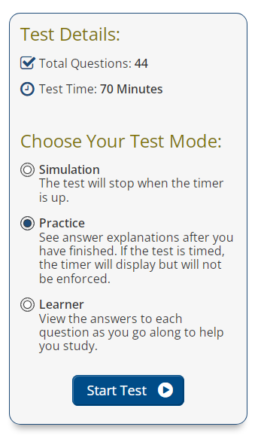

Scan here to jump to the link if using a camera enabled device.
- Fort Bend ISD
- Password: 3duc*t3

